

**HealthTrust Europe LLP: ITT to establish a framework agreement for consultancy solutions and advisory services Contract Notice (FTS) Ref: 2023-041574**

**Technical Response – D1_Quality Assurance_Ethical Healthcare Consulting**

D1: Detail the steps you will take to ensure that you meet the generally accepted industry standards for quality assurance related issues when delivering this service. Your response should include:

• quality assurance processes and standards;

• continuous improvement processes; and

• monitoring of Key Performance Indicators and Service Level Agreements.

**EHC Response:**

**• quality assurance processes and standards;**

EHC follows a comprehensive set of quality assurance processes and standards. Our commitment to quality is outlined in our Quality Handbook and is ingrained in our organisational culture.

Our quality ethos is

* We are only as good as our last job.
* We deliver sound advice and value for money for the taxpayer and the NHS.
* We don’t put our teams in situations which compromise their values or ours.
* We don’t take on work we can’t deliver – either because we don’t feel the client has asked the right question or we don’t have the skills, capacity, or capability to meet their needs.
* We don’t work with people we don’t believe share enough of our value set.
* We are open to measuring reflecting and learning where we feel we could have done better.
* We will talk to our failures openly, internally, and externally. This will encourage our staff to talk about where they feel unsure and for our clients will give them assurance that when we say we can do something, we mean it.

EHC have several policies which cover our approach to quality assurance:

1. **EHC’s Quality Policy** is a high-level statement outlining our commitment to quality. It includes our quality objectives and outlines the scope. A copy has been provided in supporting documents, *‘****SD22 SD6 EHC Quality Policy****'.*
2. **EHC’s Quality Handbook** defines the way Ethical Healthcare has implemented a quality system to assure our clients and employees of the high standards of quality that we strive to achieve and provides more detailed information about the quality management system. A copy has been provided in supporting documents, *‘****SD20 EHC Quality Handbook****’*. Our Quality Handbook serves as a comprehensive guide that outlines our quality ethos, systems, and processes. It provides a clear view of how we ensure high-quality work and how we measure it. This document is available to all employees and associates, ensuring everyone is aware of our quality standards.
3. **EHC’s Quality Strategy** outlines Ethical Healthcare Consulting’s quality ethos, systems and processes, A copy has been provided in supporting documents, *‘****SD6 EHC Quality Strategy****'.*

**EHC is working towards ISO 9001 compliance and has successfully completed the Stage 1 Assessment, with Stage 2 planned in January 2024.** This ongoing effort is part of our journey to formalise our quality management systems to meet international standards.

EHC is committed to adhering to the requirements of BS EN ISO 9001:2015. Our Quality Management System is designed to align with this international standard for quality management.

We actively review all opportunities that come into our business against our skills, capacity, and values. We assign Senior Responsible Officers (SROs) to projects to ensure that quality standards are met. We seek feedback from clients, associates, and staff to continuously improve our quality.

We have clearly defined areas of focus known as "propositions" and "capabilities." These help us address client problems effectively and efficiently. We maintain a skills matrix to track our capabilities and propositions and plan for recruitment and training accordingly.

Quality assurance processes begin with the identification of organisations and propositions that align with our capabilities. We ensure that our project teams are involved in developing bids and proposals, and we have dedicated Senior Responsible Officers (SROs) for each project.

We have a standardised project monitoring process that includes regular reporting on various aspects such as budget, plan, quality, staff, stakeholder engagement, and reputation. Any issues or red flags trigger immediate action.

We encourage a culture of continuous improvement and learning from our experiences. We conduct retrospectives, take feedback, and implement changes to enhance our processes and deliverables.

Success is measured through client retention, team satisfaction, meeting financial targets, and ensuring that retrospective reviews do not reveal repeat issues.

We have clear roles and responsibilities assigned to individuals, including Senior Responsible Officers (SROs), Quality Reviewers, Delivery Managers, Project Support Officers (PSOs), and Delivery Persons. These roles ensure that quality is maintained at every level.

Standard processes for project kick-offs are established, and performance expectations are set early in the project. This ensures that all stakeholders understand and agree on the quality standards and objectives.

Delivery managers provide weekly reporting that covers key areas such as budget management, quality assurance, and stakeholder engagement. This reporting is submitted through an online form and is reviewed by both the head of delivery and the consulting director. An example of the report reviewed is evidenced in supporting documentation *‘****SD5 EHC Project Reporting Example 211123****’.*

EHC maintains additional governance by informing the EHC board of any issues that may arise during service delivery. Corrective interventions are also reported and implemented as needed to ensure that quality is maintained. This is evidenced in our supporting documents *‘****SD7 EHC Corrective and Preventative Action Procedure****'.*

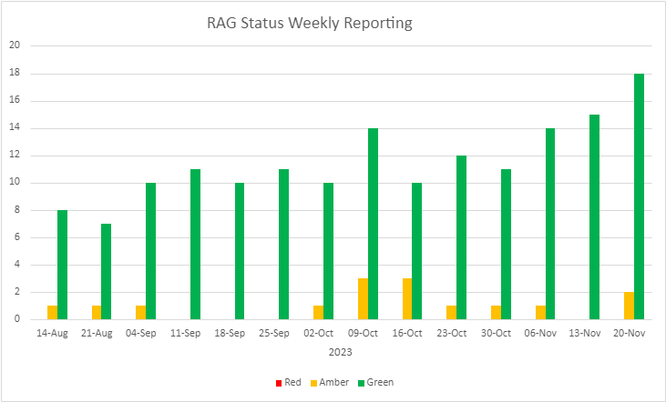

Additionally, the delivery team continuously are reviewing the delivery approaches and documentation to support our high-quality delivery output. Review of process and continuous lessons learned are fed back into the business to ensure our high delivery is always maintained.

**• continuous improvement processes**

EHC undertake regular reviews of opportunities for improvement against EHC’s skills, capacity, and values. These include:

* Feedback from clients and staff is actively sought and acted upon.
* Methodologies and templates are updated based on project retrospectives.
* Continuous training and development enhance capabilities in line with propositions.
* Retrospectives are always part of our deployments and lessons learned are implemented immediately as part of the next sprint.
* Lessons learned at the end of the project is always completed and fed back into the PMO toolkit where we collate all the information in a central repository allowing our teams to review before starting the next project.

EHC's Corrective and Preventative Action Procedure, which is provided within the supporting documents *‘****SD7 EHC Corrective and Preventative Action Procedure****’* addresses issues and potential improvements in the Information Security Management System (ISMS) and Quality Management System (QMS). Its aim is to efficiently and effectively resolve non-conformances and encourage improvements, preventing recurrence and ensuring processes, services, and controls meet specified requirements before use. Similarly, the supporting document ***‘SD24 Incident Management Procedure’*** outlines the requirements for responding to information security or quality related incidents within EHC and external reporting requirements to regulatory bodies. The Compliance Management Team ensure, through this procedure, that all information security or quality related incidents, weaknesses, or events are reported and managed.

As an example, in our previous engagement with Surrey and Borders Pathology, we demonstrated our dedication to delivering exceptional results through continuous improvement practices.

* We optimised our communication and engagement strategy to align with evolving project dynamics, saving costs and focusing on the most effective activities.
* Our strategic guidance ensured that we executed the right actions at the right times, preventing potential communication missteps and avoiding the creation of misplaced perceptions and expectations.
* EHC created a robust and sustainable platform for consistent communications and engagement, ensuring the project's success regardless of future stakeholders, while gaining active support from the Trust's communications team.

**monitoring of Key Performance Indicators and Service Level Agreements.**

Projects are consistently tracked, with regular updates and alerts to Senior Responsible Officers (SROs). To ensure our projects are successful we measure out projects in the following capacity:

* Scope – Ensuring we understand the scope, we re-iterate to our clients and agree outputs at the start of the project
* Achievable- Ensuring the budget, time and resources available, is the project achievable. This is established during the client kick of meeting
* Timeframes – Within the given timescales that the client has outlined will we achieve the outputs within time.
* Regular meetings (weekly delivery, SRO, and Board meetings) discuss and document remedial actions.
* Project conclusion processes include retrospectives and client feedback to inform future improvements.
* Success is measured through client retention, team happiness, financial performance, and learning from retrospectives. There is a weekly report expected of all delivery managers on their projects giving a temperature check of their project across the following areas
* Budget
* Plan
* Quality
* Staff
* Stakeholder
* Reputation

A red rating or an amber to red triggers an alert to the SRO which prompts action. This should not be the first time the SRO is aware of the issues flagged by the Delivery Manager but provides a reporting route into the quality dashboard to allow all projects to be viewed in one place. An example weekly report can be found within supporting documentation *‘****SD5 EHC Project Reporting Example 211123****’.*

